|  |  |
| --- | --- |
| **Department:** | **Office of the Chief Executive** |
| **Submitted by:** | Councillor Bronwyn Petrie |
| **Reference:** | **ITEM NM3/19** |
| **Subject:** | **Notice of Motion - Local Environment Plan - Crematorium** |

http://ic.tenterfield.nsw.gov.au/Open/2019/CO_27022019_AGN_AT_files/image033.png

|  |  |
| --- | --- |
| **LINKAGE TO INTEGRATED PLANNING AND REPORTING FRAMEWORK** | |
| **CSP Goal:** | **Environment** - ENVO 10 - Environmental risks and impacts are strategically managed. |
| **CSP Strategy:** | Land use planning and management enhances and protects biodiversity and natural heritage. |
| **CSP Delivery Program** | Provide systems and processes to manage excess vegetation to ensure land and premises are in a safe and/or healthy condition. |

http://ic.tenterfield.nsw.gov.au/Open/2019/CO_27022019_AGN_AT_files/image033.png

|  |
| --- |
| **SUMMARY**  The prohibition of “crematorium” as a permissible use with consent in the RU5 zoning of the current Local Environment Plan is proposed in response to community sentiment and concerns about the approval of such development within a residential area. |

|  |
| --- |
| **COUNCILLOR’S RECOMMENDATION:**    **That Council commence the process pursuant to Division 3.4 of the Environmental Planning and Assessment Act 1979, to amend Tenterfield Local Environmental Plan 2013, by including the development of a ‘crematorium’ in the RU5 Village zoning table as a Prohibited use.** |

**BACKGROUND**

The discussion and subsequent engagement around the Development Application 2018.087 – Funeral Home and Mortuary 60 Polworth Street, Tenterfield has generated significant community discussion on the location of any future proposal for a crematorium in residential areas. The current provisos under the Local Environment Plan (LEP) relating to RU5 Village zone allow for a crematorium with consent.

**REPORT:**

Below is the current extent (in pink) of the RU5 Village zone in Tenterfield:

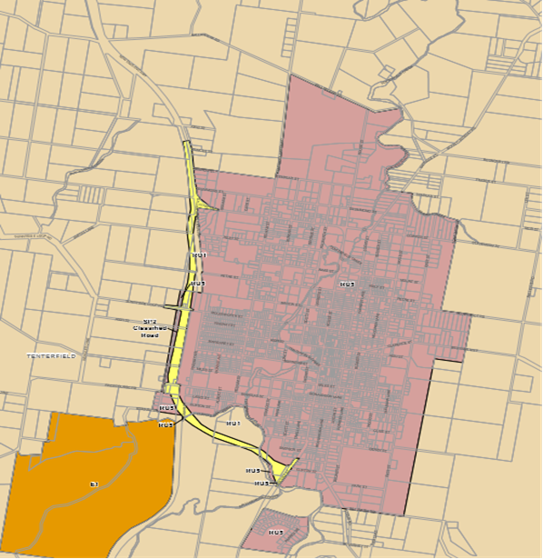

**COUNCIL IMPLICATIONS:**

**1.  Community Engagement / Communication (per engagement strategy)**

Nil.

**2.  Policy and Regulation**

•Environmental Planning and Assessment Act 1979

**3.  Financial (Annual Budget & LTFP)**

Nil.

**4.  Asset Management (AMS)**

Nil.

**5.  Workforce (WMS)**

Nil.

**6.  Legal and Risk Management**

This notice of motion, if adopted, will trigger an amendment to the existing LEP provisions, and the  incorporation of  the prohibition of a ‘crematorium’ in the RU5 Village zones will apply to all RU5 Village zoned land across the Shire including Drake, Urbenville, Liston, Legume, Torrington and Stannum.  The development of a ‘crematorium’ will remain as a permissible use in the RU1 Primary Production zone across the Shire based on the proposed motion.

**7.  Performance Measures**

Nil.

**8.  Project Management**

It is intended that a review of the LEP and a subsequent LEP Amendment (referred to as a ‘housekeeping’ amendment) will be commenced in the first 3 months of 2019, in line with Accountability Framework DP13.08 in the 18/19 Operational Plan. As such this item could be included in the review with little impost on current resourcing.

**Bronwyn Petrie**

**Councillor**

|  |  |
| --- | --- |
| Prepared by staff member: | Councillor Bronwyn Petrie |
| Department: | Office of the Chief Executive |
| Attachments: | There are no attachments for this report. |